A Project Documentation on:

Expense Tracker

**TABLE OF CONTENTS**

1.Introduction 03

2.Hardware/Software Requirements 04

3.Setup /Build Process 05

4.App Features 07

5.System Testing 17

6.Conclusion/Future Enhancements 17

7.References 17

**1.Introduction:**

Who doesn’t have a goal for the new year that involves money? Many of us have goals that involve making more money or managing the money we already have — but, no matter exactly what goal you might have for your money, you’ll probably need some baseline information about it. While understanding your expenses is basic, they make up some of the most vital information you can gather about where your money goes. Tracking expenses can be a relatively simple matter and can provide you so much information about your spending habits. Expense Tracker is one such web application which makes this task easy. This provide a user account to create ,edit , delete and track the expenses through a expense list.

**2.Hardware/Software Requirements:**

**Hardware Requirements:**

* Processor: Pentium Dual Core
* Speed : 2.30 GHz
* RAM : 1 GB
* Hard Disk: 15 GB

**Software Requirements:**

* Operating System: Windows 10
* Web Technologies: HTML,CSS,Javascript,Django Template Library
* Backend Technologies: Python(3.5.0)/Django(Version-1.8)
* Database :MySQL

**3.Setup /Build Process:**

Follow the below steps to setup the environment for the project:

1.Create a virtual environment

**python -m virtualenv env_name**

2.Move to Scripts folder inside the virtual environment and run activate.bat to activate the environment.

3.Install Django (Make sure python 3.5.0 is installed and path is set)

**pip install django ==1.8.6**

4.Create the new project track_expense.

**django-admin startproject track_expense**

5.Create the app after the project.

**django-admin startapp expense**

6.Mention the ‘expense’ app under installed apps in settings.py.

Installed_Apps=(………………..,

expense,

)

7.Making the Database changes/Initialization.

**create database track_expense character set utf-8;**

**grant all privileges on track_expense.* to chandan@localhost;**

**flush privileges;**

8.Install mysql client.

**pip install mysqlclient==1.3.12**

9.Do the below database changes in settings.py file:

**DATABASES = {**

**'default': {**

**'ENGINE': 'django.db.backends.mysql',**

**'NAME': 'track_expense',**

**'USER': 'chandan',**

**'PASSWORD': 'root',**

**'HOST': 'localhost',**

**'PORT': '3306',**

**'TEST': {**

**'NAME': 'track_expense_test',**

**},**

**}**

**}**

10.The virtual environment should be installed with below packages.

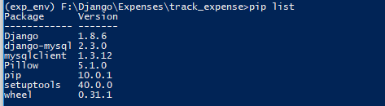

**4.App Features :**

1.User Registration:

A new user can register using register form.

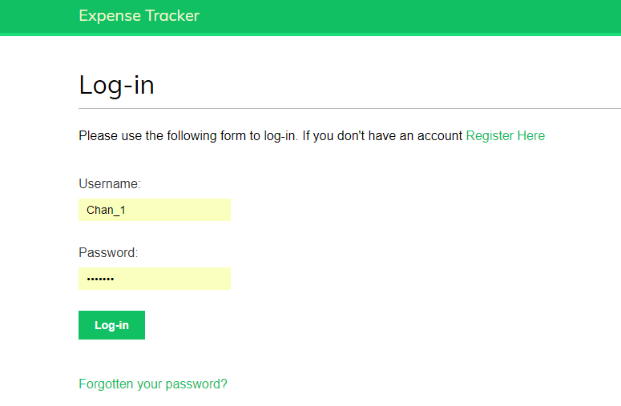

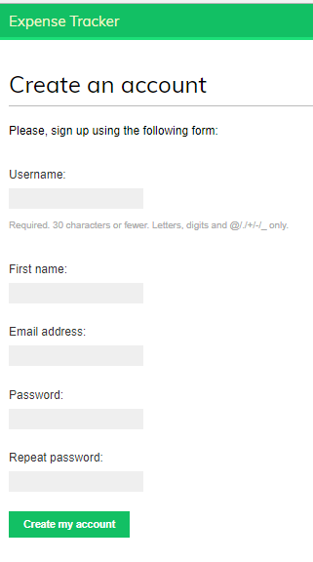

2.Adding Expense

Login with registered user and add the expense though add expense hyperlink.

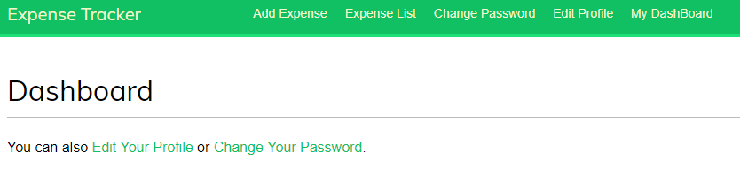

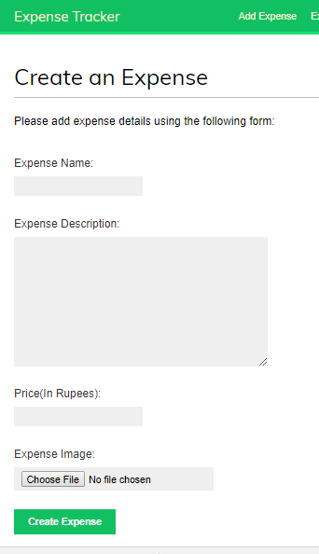

3.Expense List Report

Expense list report to view expenses added and Total Expense.

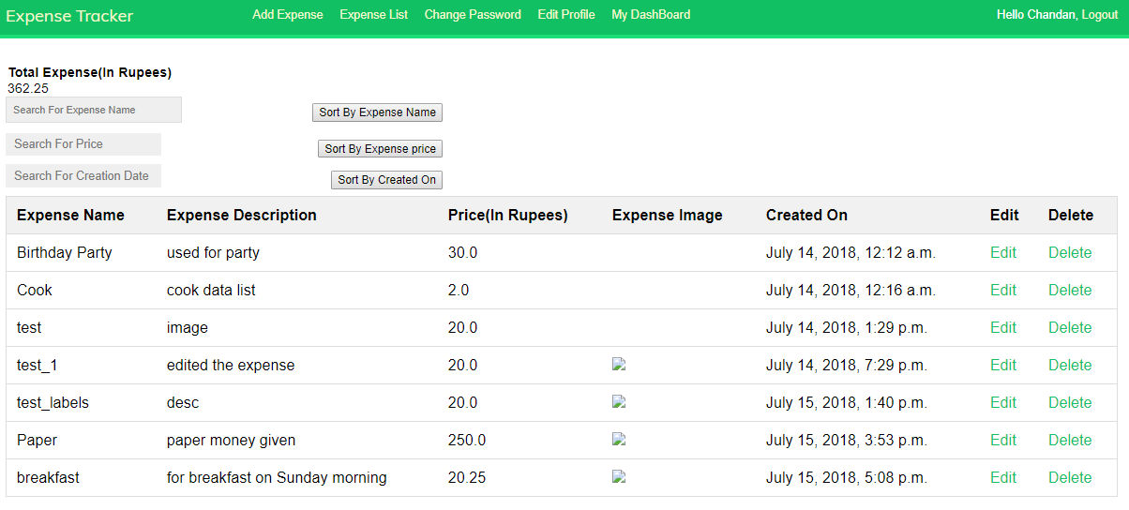

4.Edit the expenses added

The expenses can be edited by clicking on Edit link and confirming the pop up that appears.

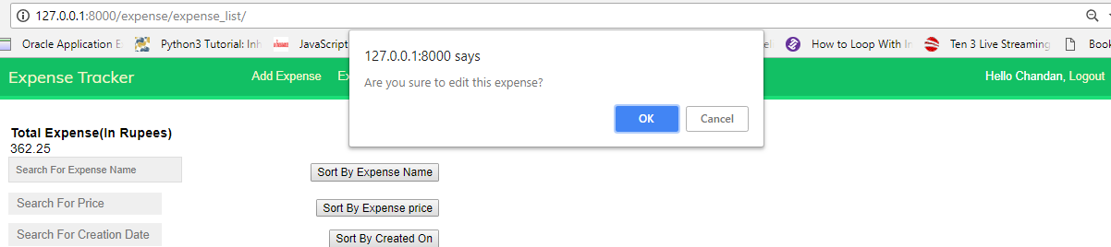

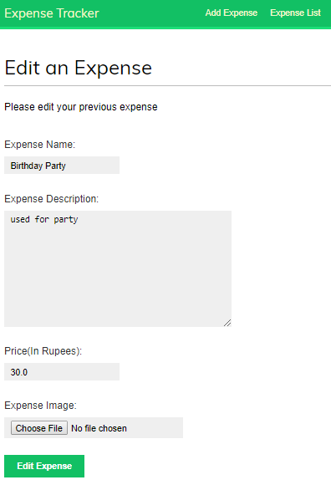

5.Delete the Expense

Unwanted expense can be deleted by clicking on Delete link and confirming the pop up that appears.

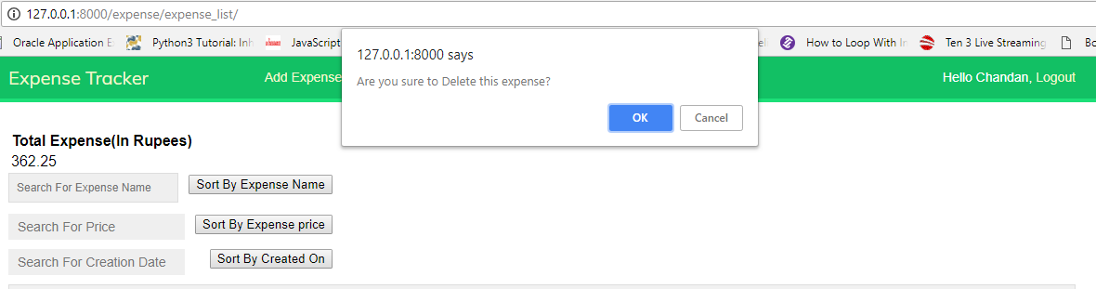

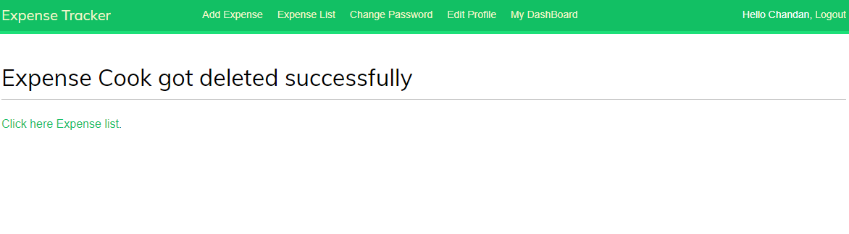

6.Search/filter with Expense Name, Price and Creation Date.

(i)Filter By Expense name

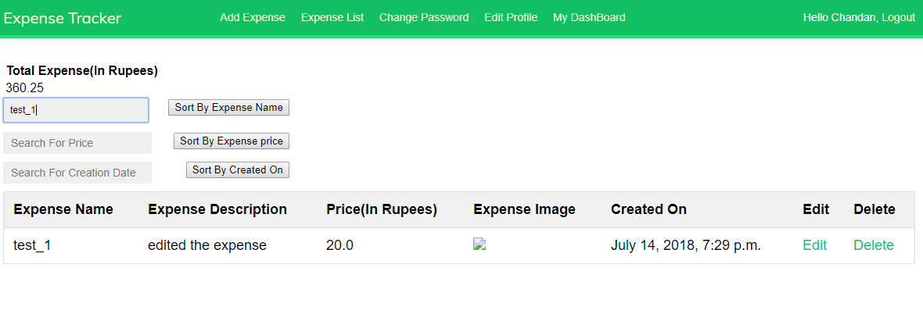

(ii)Filter By Expense price

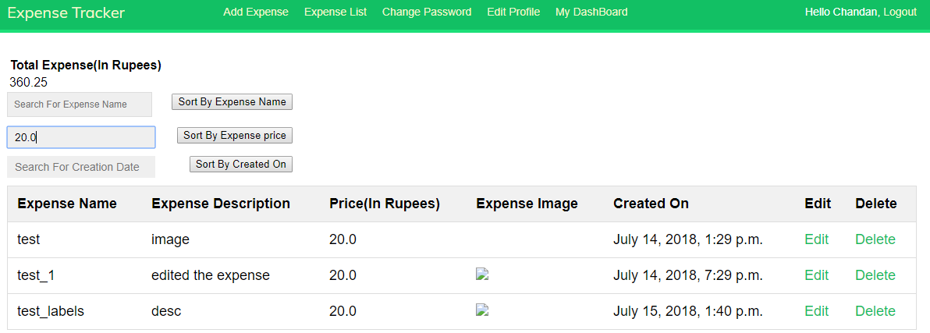

(iii)Filter By Creation Date

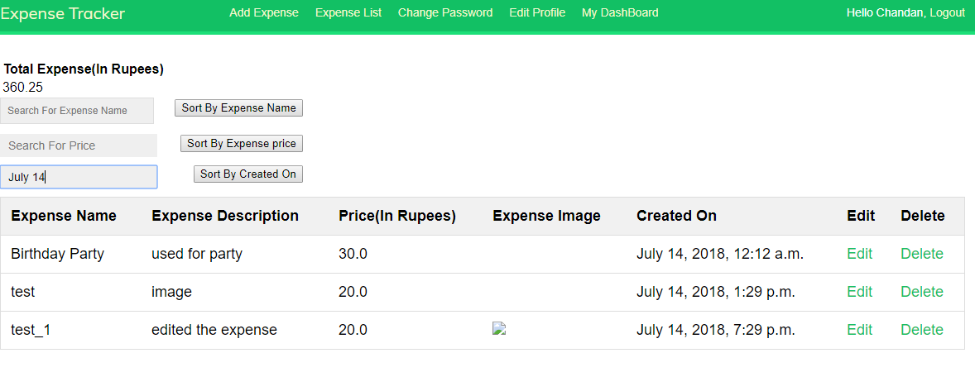

6.Sort with Expense Name, Price and Creation Date.

(i)Sort By Expense Name

Click on “Sort By Expense Name” button to sort(sorts in ascending order)..

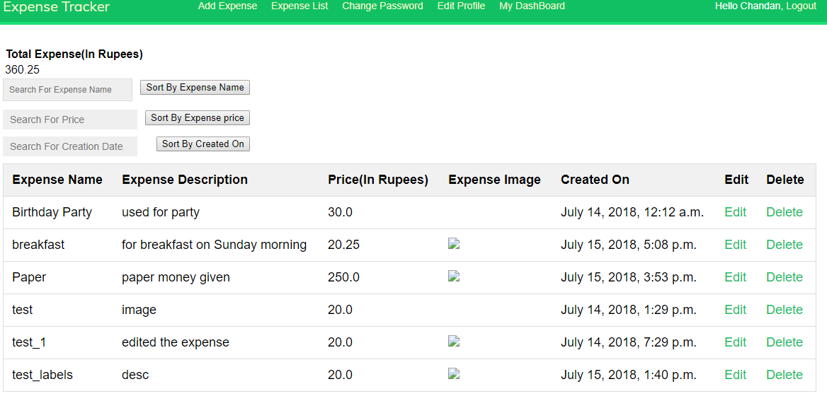

(ii)Sort By Expense price.

Click on “Sort By Expense Price” button to sort(sorts in ascending order).

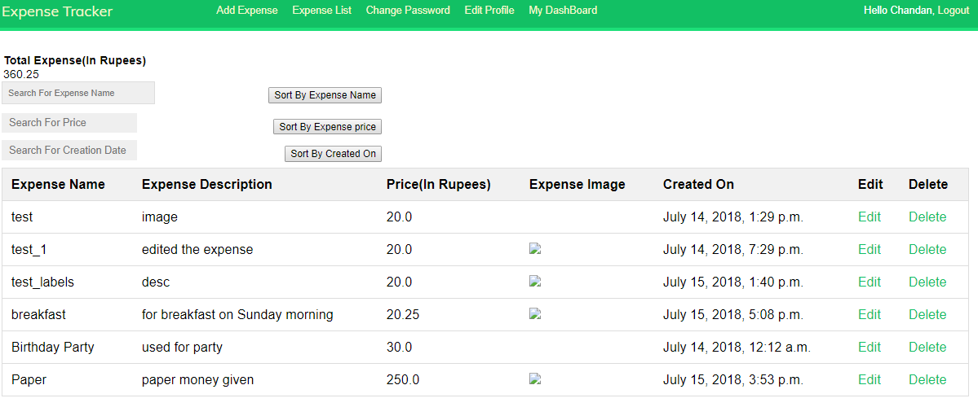

(iii)Sort By Creation Date.

Click on “Sort By Creation Date” button to sort(sorts in ascending order).

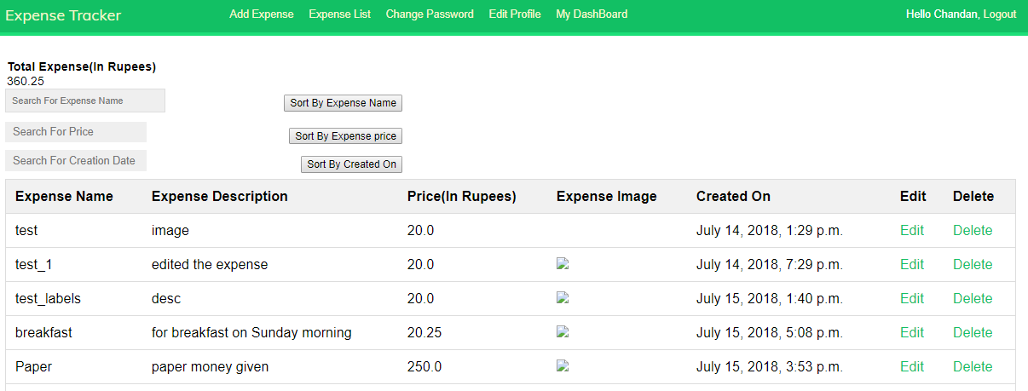

7.Change Password.

The user can change password by clicking on change password.

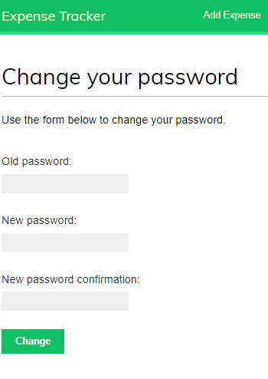

8.Edit Profile.

User can edit profile by clicking on edit profile.

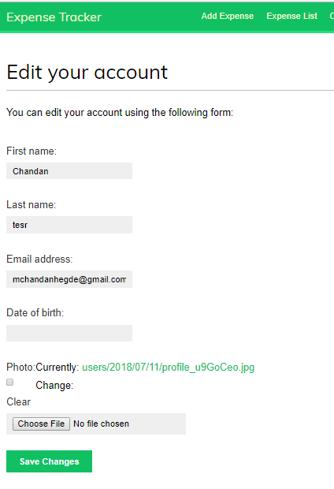

**5.System Testing**

The below excel sheet contains the test cases executed.



**6.Conclusion and Future Enhancements:**

The Expense Tracker allows the user to track all the expenses with ease. User can view,edit,delete,filter and sort the expenses in a single webpage.

The app enhancement may include features like expense category, expense graphs, budget for month/expense comparison, split the expense between different users .The user interface/User experience may be enhanced with new designs.

**7.References**

* stackoverflow.com
* docs.djangoproject.com
* djangobook.com